The Compliance Monitoring Data Portal (CMDP) Training Materials

Module 1: CMDP Overview

Introduction
The CMDP is a web-based data reporting system comprising several components, including a web application, web services, and synchronization tools. Its purpose is to enable laboratories and public water systems to electronically report compliance sample results to primacy agencies (e.g., state agencies).
The primary components of the CMDP system are the web-based software application and relational database. In addition to the web application and database, there are several other software components supporting the CMDP system including (see figure below):
- MS Excel Templates that support reporting sample results in an XML file uploaded manually
- Web Services that support reporting sample results in an XML file using a Laboratory Information Management System (LIMS)
- Web Services that support SDWIS/State users
- The Data Synchronization Engine (DSE) that supports two-way data exchange between CMDP and SDWIS/State
- A Shared CROMERR Services web application for registration and end-user management
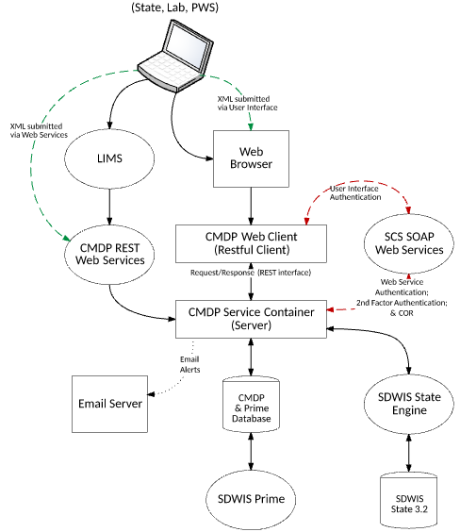
There are six System Module Tabs in CMDP: Home, PWS Profiles, Laboratory Profiles, Drinking Water Sample Jobs, Search Individual Samples, and System Administration.
- Home: These are the landing pages for each CMDP user type that allow a lab or utility to view draft and final submittals, states to view final submittals, links to Profiles associated with the user, and Change Requests. The Home page consists of one or more dashboards.
- PWS Profiles: The Profiles are the read-only view of inventory and legal entity information for each water system assigned to a PWS user or to which a Lab user has access. Profile Change Requests may be made by a water utility when information in a Profile changes. States may review and approve Profile Change Requests in CMDP.
- Laboratory Profiles: The Profiles are the read-only view of legal entity information for each laboratory assigned to a Lab user. Profile Change Requests may be made by a laboratory when information in a Profile changes. States may review and approve Profile Change Requests in CMDP.
- Drinking Water Sample Jobs: This module represents the core functionality of CMDP, which is to support the preparation, workflow, and electronic submittal of drinking water sample results to state primacy agencies. Web forms have been created for the following categories: microbiological, chemical/radiological, composite samples, Cryptosporidium, and operational samples.
- Search Individual Samples: This module supports searching for any submitted Sample Jobs by one or more of a broad range of criteria (Job ID, Job Status, Water System Name, Water System ID, Facility, Collection Date Range, Sample ID, Sample Type, Sample Category, Analyte, Laboratory ID, etc.).
- System Administration: Through this CMDP module, states have the ability to manage and approve Profile Change Requests and configure system email notifications. (Right now, there are no functions for other User Roles.)

Samples and Sample Results Data Entry
The CMDP accepts sample results from laboratories and water utilities using three different electronic reporting methods:
- Web-services (i.e., ReST API) for connecting submitter data management systems to CMDP (these are one-way services)
- Uploaded XML files including XML files generated from CMDP Excel templates into which samples and results can be entered on your computer
- Direct data entry using web forms
The CMDP supports the following types of samples and results:
- Microbiological including for example:
  - Total coliform,
  - E. coli,
  - Coliphage,
  - Enterococci
  - Cryptosporidium
- Chemical and radionuclides including:
  - inorganic chemicals
  - organic chemicals (VOCs and SOCs)
  - radionuclides
- Composite samples for radionuclides and chemicals
- Operational parameters including:
  - turbidity
  - disinfectant residuals
  - LCR water quality parameters
- Calculated operational sample information including:
  - Locational Running Annual Averages (LRAA) for TTHM and HAA5
  - % Reduction of total organic carbon (TOC)

Water System and Laboratory Information
Information for laboratories and public water systems (PWS) are read by the CMDP from the primacy agencies drinking water compliance system, which is currently SDWIS/State for the large majority of state primacy programs, and beginning in 2018, which will be the new SDWIS (Prime) for states that adopt it as their new compliance data management system. The PWS information currently read by the CMDP includes PWS Name, PWS ID, primary and secondary administrative contacts, water system facilities, and sampling point IDs. The laboratory information currently read by the CMDP includes administrative contacts along with laboratory name and laboratory ID.
Until SDWIS Prime is fully developed and used by all current SDWIS/State users, the CMDP’s Data Synchronization Engine (DSE) will synchronize PWS and laboratory information between the CMDP and SDWIS/STATE. Primacy agencies that don't use SDWIS/STATE, but instead use a state-specific drinking water compliance system can develop their own synching application which could then utilize the same CMDP web services used by the DSE. The CMDP web services and their functions are outlined in the CMDP State Database Interface Control Document (ICD).
Though the data for water systems and laboratories are maintained by primacy agency personnel, the CMDP enables both water system and laboratory users to use the CMDP to request changes to their Profile information in SDWIS/State or other state compliance system.
Ensuring that the data for water systems and laboratories is current enables the CMDP to properly validate samples and results while they are submitted to CMDP, thus reducing errors and improving data quality.

Login for the CMDP
To log into the CMDP with your credentials obtained from Shared CROMERR Services (SCS), go to the internet address for the CMDP (https://cmdp.epa.gov/cmdp). The address for the picture below is not the one you’ll use when you are actually using the CMDP to report samples and results to your primacy agency so it is partially hidden.

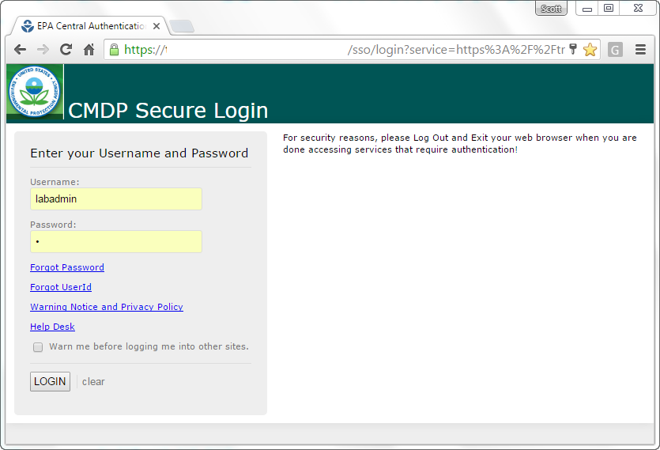
The login screen looks like many login screens you encounter in a web-based application. Enter your Username and Password and then click on the LOGIN button. If you don’t have a Username and Password, you’ll need to register for an account using Shared CROMERR Services (SCS). Click on the Help Desk link for refer to the CMDP User Guide for instructions on how to register.

CMDP Roles and Dashboards
After you log in, you’ll see your Home page, which includes a dashboard specific to your “role.” Below is the dashboard that a laboratory user will see.
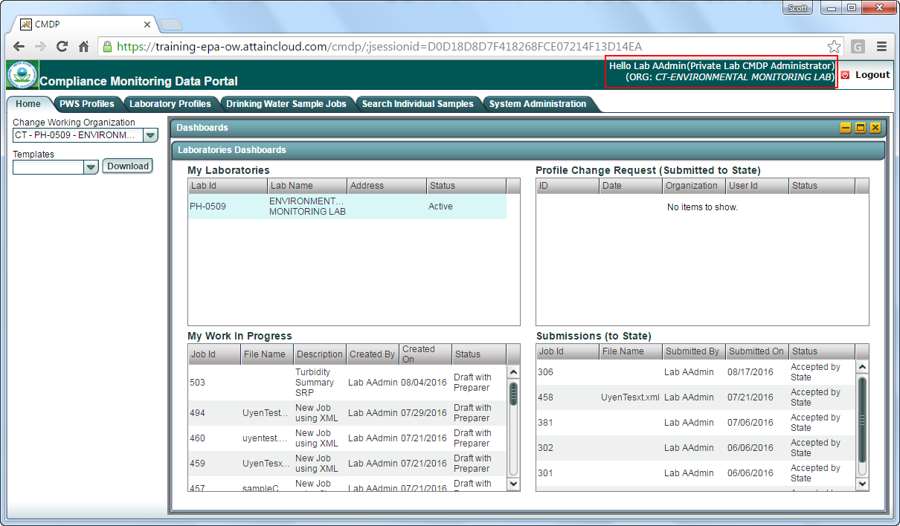
View of the Home page for Laboratory Users
If you are a water system user, your dashboard will look similar because a Laboratory User and a Water System User are both submitters. The Water System User dashboard is shown below. Notice that the "My Laboratories" changes to "My Water Systems" for a Water System User.
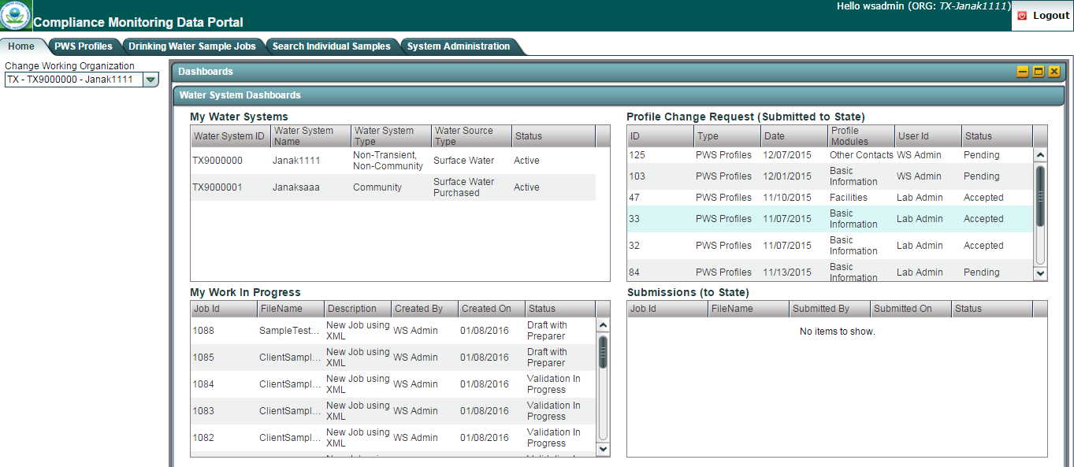
View of the Home page for Water System Users
The dashboard for a State User, however, is different. That is because a State User is not a submitter, but rather receives sample data and profile change requests. As a result, the State User dashboard contains jobs and profile change requests received (see below).
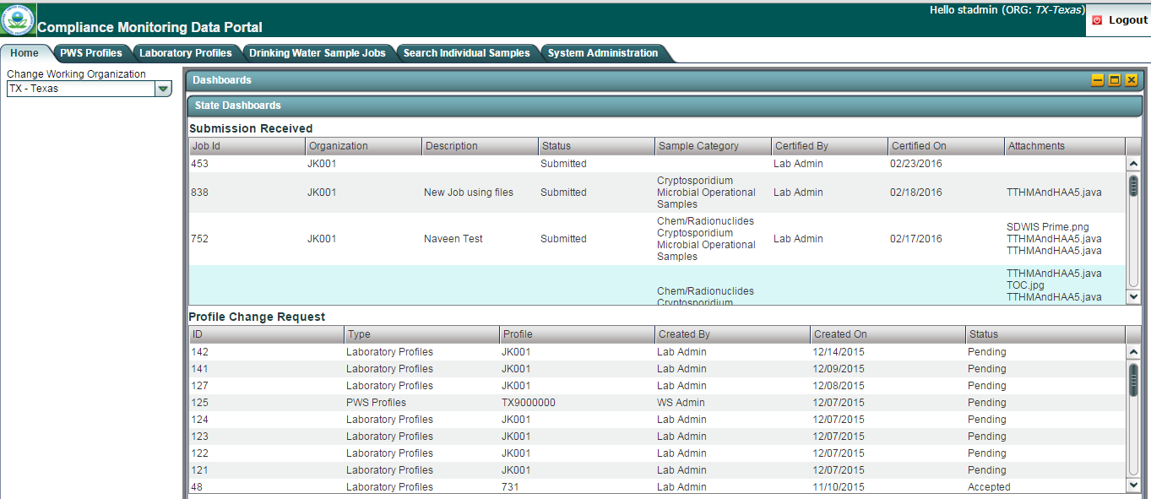
View of the Home page for State Users
Regardless of your account information; your login, role and organization are displayed on the top right corner of the homepage (see the red box in the first homepage picture above). Also, if your account is associated with multiple entities, you can use the “Change Working Organization” to select from those entities.

