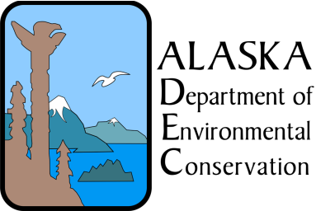
 |  |  | NOTICE OF TERMINATION FORM

NOTICE OF TERMINATION (NOT) - REQUEST TO WITHDRAW FROM THE WASTEWATER GENERAL PERMIT 2009DB0026 FOR LARGE COMMERCIAL PASSENGER VESSELS OPERATING IN ALASKA
(See Section 1.11.2 of the permit)
VESSEL OWNER INFORMATION
Who is the main point of contact for the vessel? (e.g. owner, operator, or Alaska Agent)
Owner Business Name: |  |  |  | Phone Number:
Address: |  |  |  | Fax Number:
City, State, Zip: |  |  |  | Email Address:
Representative:
VESSEL OPERATOR'S BUSINESS NAME IF DIFFERENT FROM THE OWNER’S BUSINESS NAME
Operators Business Name:
Address: |  |  |  | Phone Number:
City, State, Zip: |  |  |  | Fax Number:
Representative: |  |  |  | Email Address:
VESSEL INFORMATION
Vessel Name:
Vessel IMO Number:
Port of Registry:
Date of Termination of Wastewater Discharges into Marine Waters of the State:

 |  |  | Check one of the following boxes
This vessel has left Alaskan waters and will not be discharging in marine waters of the state.
This vessel is no longer owned or operated by the original permittee.
This vessel will continue to operate in marine waters of the state. A Vessel Specific Holding Plan detailing holding tanks that shall be used and procedures that shall ensure that a discharge of waste water will not occur in marine waters of the state is included with this request for termination.
Signature and Certification for NOT
Certification: |  | I certify under penalty of law that this document and all attachments were prepared under my direction or supervision in accordance with a system designed to assure that qualified personnel properly gather and evaluate the information submitted. Based on my inquiry of the person or persons who manage the system or those persons directly responsible for gathering the information, the information submitted is, to the best of my knowledge and belief, true, accurate and complete. I am aware that there are significant penalties for submitting false information, including the possibility of fines and imprisonment for knowing violations.  I understand that by submitting this Notice of Termination I am no longer authorized to discharge wastewater into marine waters of the state as defined in AS 46.03.490(8) and AS 46.03.490(18). I also understand that the submittal of this Notice of Termination does not release an owner or operator from liability for any violations of this permit.
Signature: |  |  |  |  |  | Dated:
Printed Name:
Title:

SUBMIT COMPLETED NOTICE OF TERMINATION TO:
Alaska Dept. of Environmental Conservation
Division of Water
Commercial Passenger Vessel Environmental Compliance Program
410 Willoughby Avenue, Suite 303
PO Box 111800
Juneau, AK 99811-1800
(907) 465-5300

